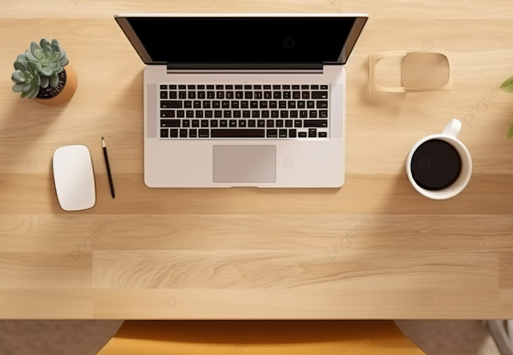
The objects I have chosen to replicate from my scene are the laptop, pencil, mouse, and coffee. I believe these items are a good choice for my work because although they are relatively simple, they should allow me to create a more realistic and presentable scene. The item I have decided to leave out was the plant, due to the leaves requiring a more complex shape.
To create the laptop, I would first extend two boxes into rectangles and connect their sides at a 45 degree angle. I would then use small boxes to create the keyboard and mousepad.
To create the mouse, I would either flatten a cylinder or box to the size of the mouse due to its minimalistic design.
To create the pencil, I would use a cylinder to create the base, then attach a pyramid to the end to represent the graphite point.
To create the coffee, I would use a tapered cylinder to represent the base of the coffee cup, since it would accurately represent how a cup widens as it gets taller. I would then use a flattened torus, and hide half of it into the coffee cup to represent the handle.

Reflection
I decided to pick this 3D scene because it is something that every person has seen in their lives, whether it be at home, school, or work. I decided to pick a laptop and mouse as I believed the textures required would be easily implementable and would clearly show the reflection of light. For my other two objects, I chose a cup of coffee and a pencil. The coffee was the most difficult part of the scene, requiring multiple carefully placed shapes to form. The pencil was one of the simpler objects to implement, but required some basic math to ensure the tip was connected. Overall, my scene was justified because the objects required were easily replicable and can be used to perfectly exemplify the goal of each milestone.

Users can navigate my scene using W, A, S, D to control the movement of the camera and using the mouse to control the aiming of the camera. This simple design allows users to move the camera 360 degrees in any direction they please. I have additionally added an up and down function with Q and E to easily allow users to move up and down without having to pan their camera. Finally, the user is abl;e to switch between an orthographic display and a perspective display using O and P.

Some custom functions I implemented into my program were the Loadtextures function, SetupSceneLights function, and defineObjectMaterials function. The loadtextures function allowed for users to quickly load textures from the textures folder. This would then be used before drawing an object to apply any loaded texture. The SetupSceneLights function was the most difficult to set up, allowing for illumination of the scene. By creating multiple spotlights, I was able to fully illuminate the plane of the scene. The defineObjectsMaterials set up the shader material for each object. Similar to the textures function, it is quickly applied before drawing the object.

References
PNGTree. (n.d.). 3D rendered top view of laptop computer mockup on a wooden table creating a minimalistic and efficient workspace [Digital image]. https://pngtree.com/freebackground/3d-rendered-top-view-of-laptop-computer-mockup-on-a-wooden-table-creating-a-minimalistic-and-efficient-workspace_13279662.html

